Regression Model Comparison Report

Project Title
House Price Prediction Using Regression Machine Learning Models

1. Problem Definition
House price prediction is a regression machine learning problem where the objective is to predict continuous house prices based on different property features.
In this project, multiple regression algorithms are trained, evaluated, and compared to identify the best-performing model for predicting house prices.
The target variable is the house price, while features such as area, number of bedrooms, bathrooms, stories, parking, location-related facilities, and furnishing status are used as independent variables.

2. Dataset Description

Dataset Name
Housing.csv

Dataset Size
- Number of Records: 545
- Number of Features: 12 input features
- Target Variable: price

Independent Variables
The dataset contains the following input features:
- Area
- Bedrooms
- Bathrooms
- Stories
- Main Road Access
- Guest Room Availability
- Basement Availability
- Hot Water Heating
- Air Conditioning
- Parking Spaces
- Preferred Area
- Furnishing Status

Dependent Variable
- House Price (price)
The dependent variable is continuous, therefore regression algorithms are suitable for this problem.

3. Data Preprocessing Steps
Before training machine learning models, data preprocessing was performed.

3.1 Data Loading
The dataset was loaded using the Pandas library.

3.2 Data Exploration
The following analysis was performed:
- Displayed first five records
- Checked dataset dimensions
- Checked column names
- Analyzed data types
- Generated statistical summary

3.3 Missing Value Handling
Missing values were checked using the isnull() function.
Result:
- No missing values were present in the dataset.

3.4 Duplicate Removal
Duplicate records were checked and removed to improve data quality.

3.5 Encoding Categorical Variables
Categorical features such as:
- Main road
- Guest room
- Basement
- Air conditioning
- Furnishing status
were converted into numerical format using One-Hot Encoding.

3.6 Train-Test Split
The dataset was divided into:
- 80% Training Data
- 20% Testing Data
using train-test split with random_state = 42.

4. Baseline Model
The baseline model used in this project was:

Linear Regression
Linear Regression was selected as the baseline because it is a simple and commonly used regression algorithm.
It establishes a performance reference that can be compared with more advanced models.

5. Regression Models Implemented
The following regression algorithms were trained and evaluated:

5.1 Linear Regression
A simple regression model that predicts the target value by finding the linear relationship between input variables and output.
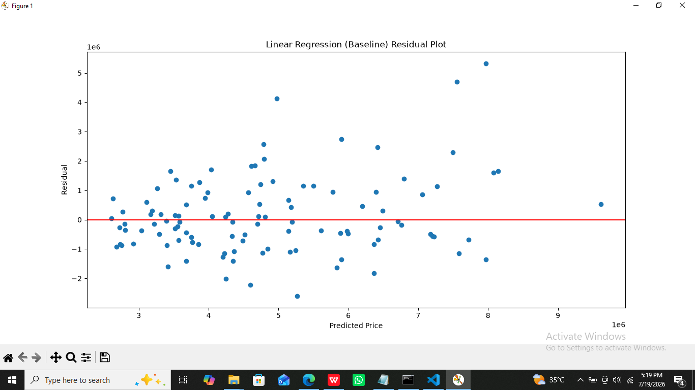

5.2 Ridge Regression
Ridge regression applies L2 regularization to reduce overfitting and improve model stability.
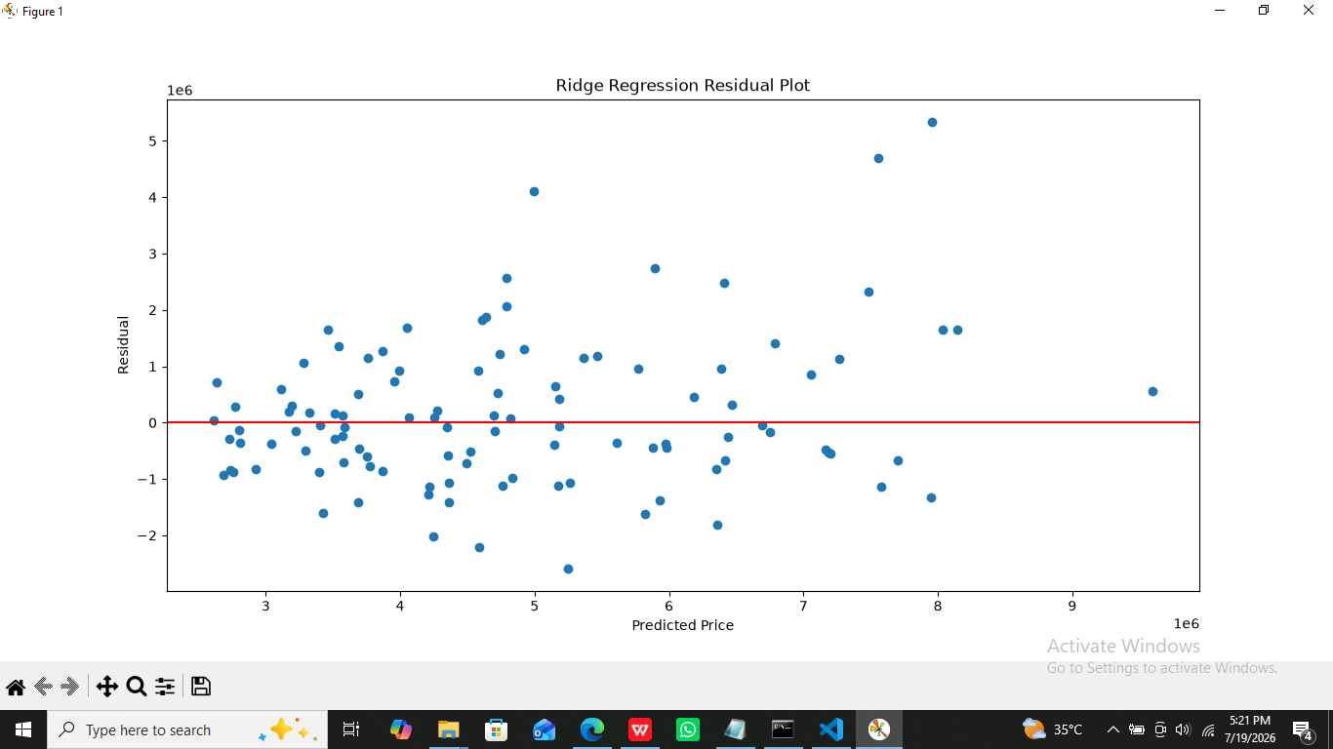

5.3 Lasso Regression
Lasso regression uses L1 regularization and can reduce the impact of less important features.
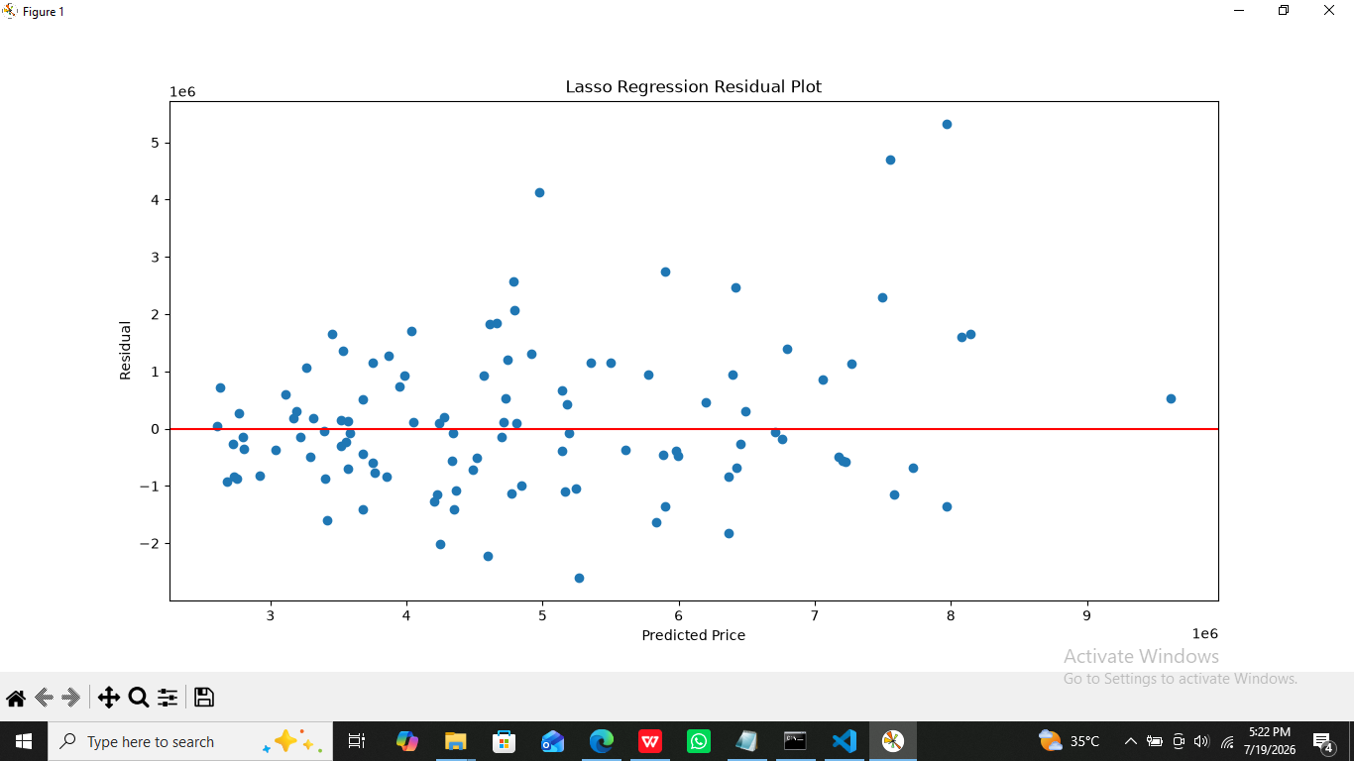

5.4 Elastic Net
Elastic Net combines both L1 and L2 regularization techniques.
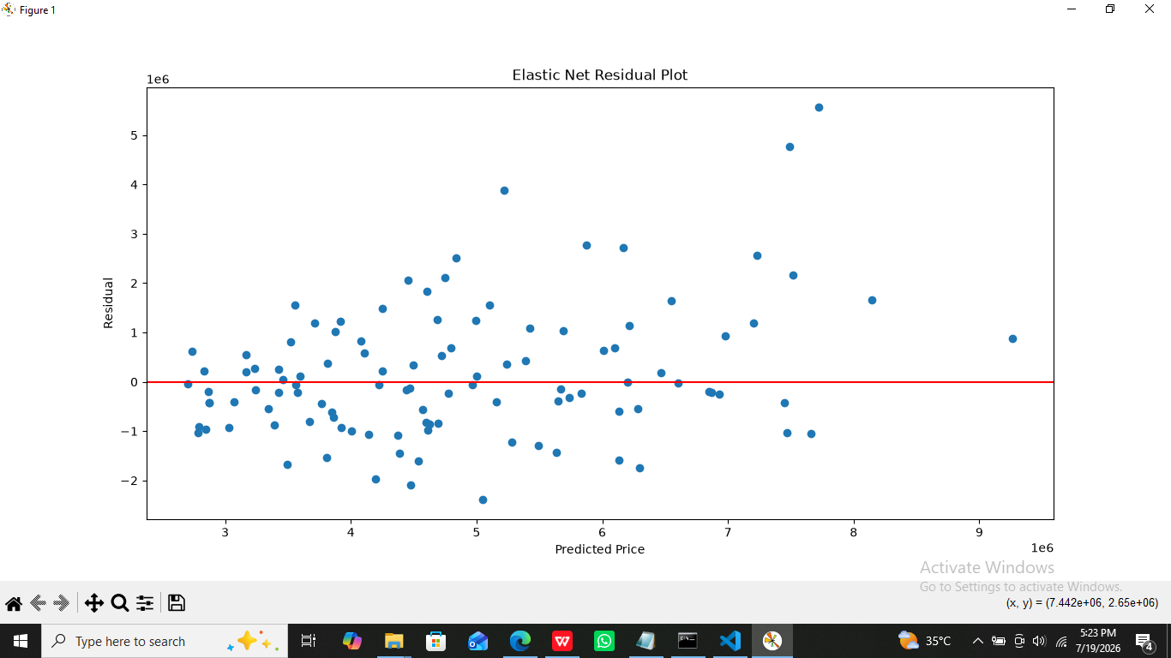

5.5 Polynomial Regression
Polynomial regression captures non-linear relationships by adding polynomial features.
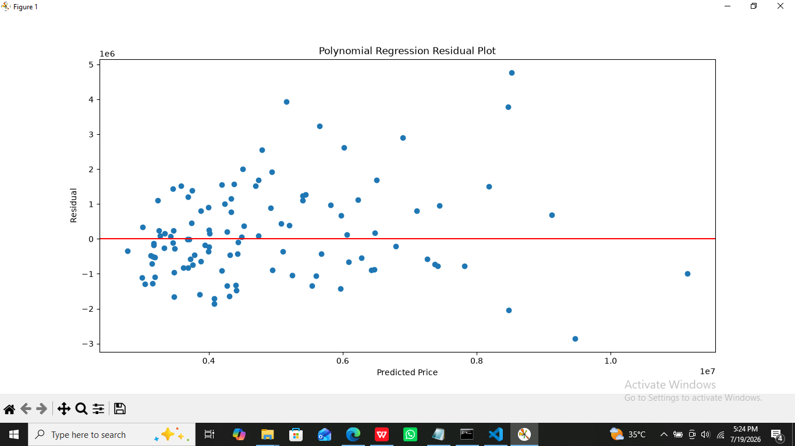

5.6 Decision Tree Regressor
Decision Tree divides data into decision-based rules to perform predictions.
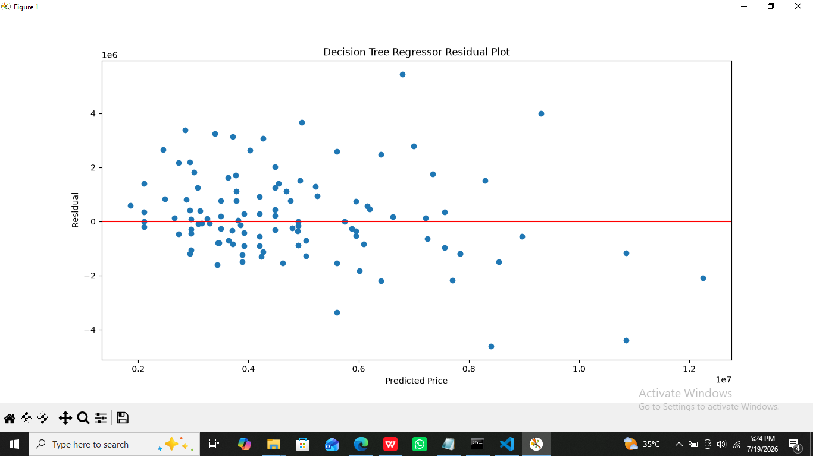

5.7 Random Forest Regressor
Random Forest combines multiple decision trees to improve prediction accuracy and reduce variance.
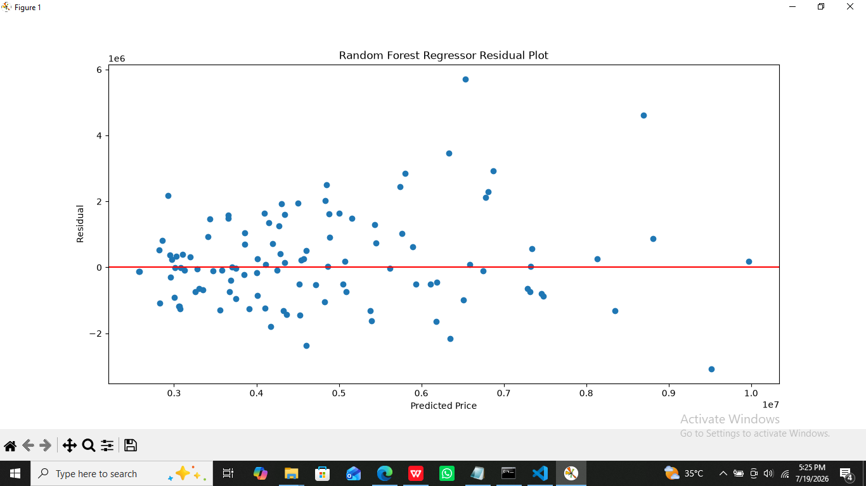

5.8 Gradient Boosting Regressor
Gradient Boosting builds models sequentially to reduce prediction errors.
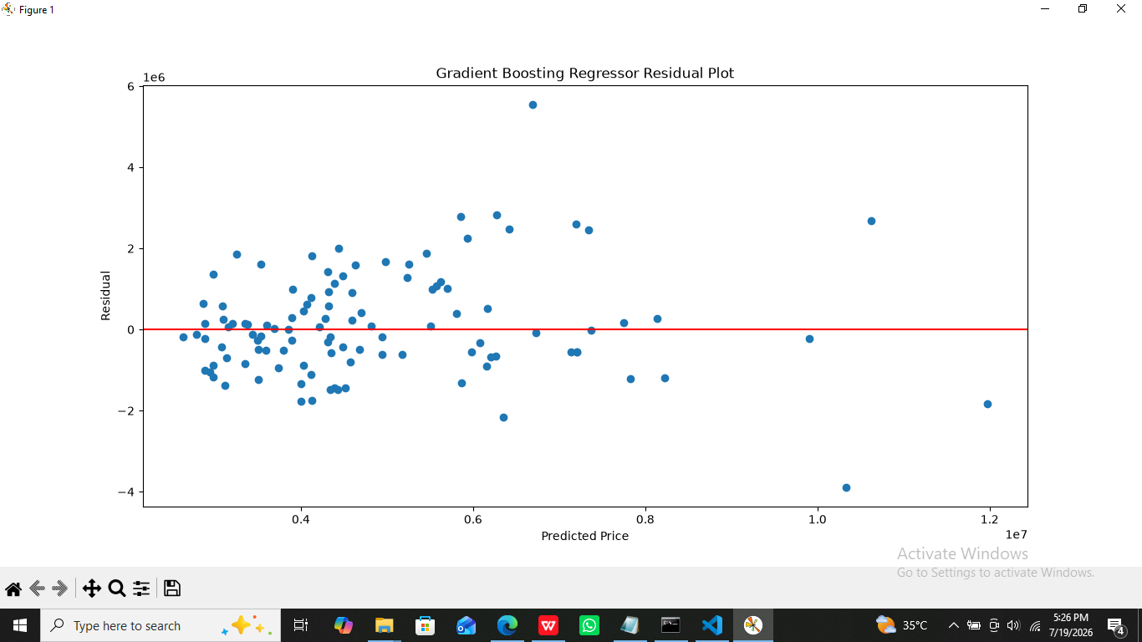

5.9 XGBoost Regressor
XGBoost is an advanced boosting algorithm that improves prediction performance through optimized decision trees.
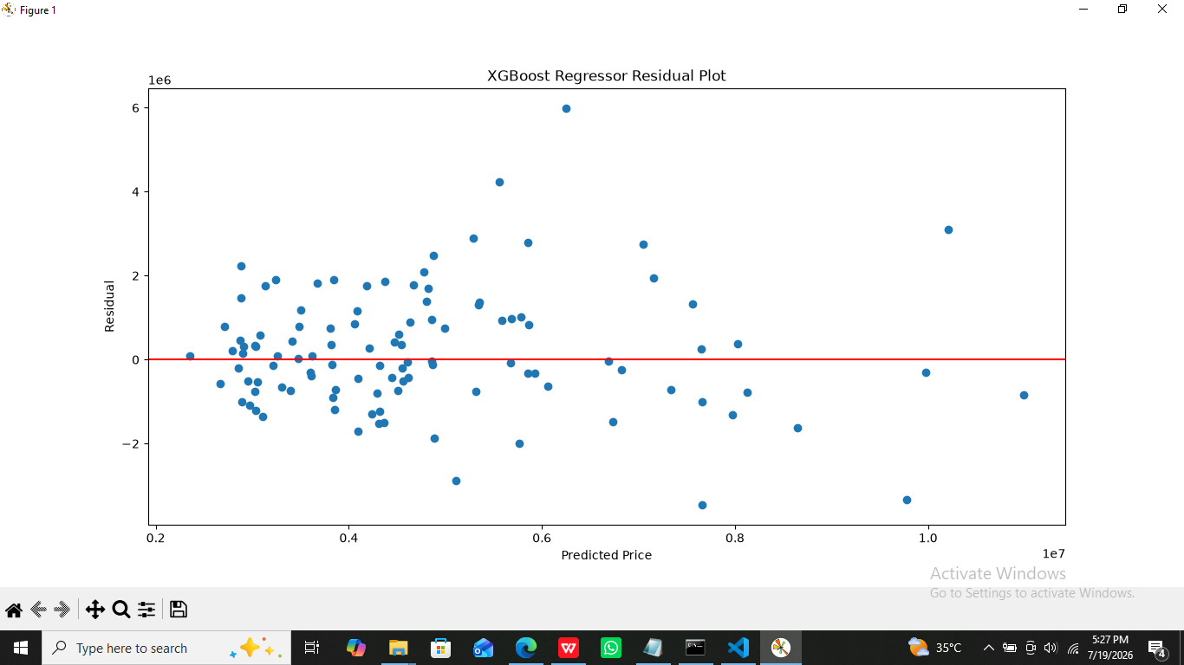

6. Evaluation Metrics
The models were evaluated using the following metrics:

Mean Absolute Error (MAE)
MAE measures the average absolute difference between actual and predicted values.
Lower MAE indicates better performance.

Mean Squared Error (MSE)
MSE calculates the average squared difference between predictions and actual values.

Root Mean Squared Error (RMSE)
RMSE is the square root of MSE and represents prediction error in original units.

R-Squared Score (R²)
R² shows how much variation in the target variable is explained by the model.
Higher R² indicates better performance.

Adjusted R²
Adjusted R² considers the number of features and provides a more accurate evaluation.

Mean Absolute Percentage Error (MAPE)
MAPE represents prediction error as a percentage.

7. Model Comparison Results
Model | R² Score | RMSE
Linear Regression | 0.6529 | 1324507
Ridge Regression | 0.6525 | 1325320
Lasso Regression | 0.6529 | 1324507
Elastic Net | 0.6415 | 1345989
Polynomial Regression | 0.6557 | 1319134
Decision Tree | 0.4771 | 1625670
Random Forest | 0.6119 | 1400566
Gradient Boosting | 0.6650 | 1301270
XGBoost | 0.5850 | 1448271

8. Cross Validation Results
Repeated K-Fold Cross Validation was applied with:
- Number of folds: 10
- Repetitions: 3
Cross-validation helped evaluate model stability and generalization performance.
The best cross-validation performance was achieved by:
Polynomial Regression
with approximately:
Cross Validation R² = 0.6397
Gradient Boosting also showed strong and stable performance.

9. Residual Analysis
Residual analysis was performed to analyze prediction errors.
Residual:
Residual = Actual Value - Predicted Value
Residual plots were generated for each model.
A good regression model should have:
- Residuals distributed randomly
- No clear pattern
- Errors close to zero
The residual plots helped identify prediction errors and model behaviour.

10. Model Behaviour Analysis

Bias
High bias occurs when a model is too simple and cannot capture important patterns.
Example: Linear Regression may have higher bias for complex relationships.

Variance
High variance occurs when a model learns training data too closely.
Example: Decision Trees may suffer from high variance.

Overfitting
Overfitting occurs when a model performs very well on training data but poorly on unseen data.

Underfitting
Underfitting occurs when a model is too simple and performs poorly on both training and testing data.

11. Final Model Selection
Based on evaluation results, the recommended final model is:

Gradient Boosting Regressor
Reasons:
- Highest R² Score: 0.665
- Lowest RMSE among tested boosting/tree models
- Good balance between bias and variance
- Better generalization compared to other models
Therefore, Gradient Boosting Regressor was selected as the final prediction model.

12. Error Analysis
The model still produces some prediction errors because house prices depend on many external factors.
Possible reasons:
- Limited dataset size
- Missing important features
- Economic conditions are not included
- Location information is limited
Adding more relevant features could improve prediction accuracy.

13. Limitations
The project has the following limitations:
- Dataset contains only 545 records.
- External market factors are not included.
- Hyperparameter tuning was not extensively performed.
- Model performance depends on dataset quality.
- Predictions may not represent real-time market prices.

14. Conclusion
In this project, multiple regression machine learning algorithms were developed and compared for house price prediction.
Different evaluation metrics and cross-validation techniques were used to analyze model performance.
Among all tested models, Gradient Boosting Regressor achieved the best overall performance with the highest R² score.
The project demonstrates how regression algorithms can be applied for continuous-value prediction problems and how different models can be evaluated to select the most suitable solution.

